|  |  |  |  |  |
| --- | --- | --- | --- | --- |
|  | **Coway BA13 A / B** | **Coway BA08** | **EcoBidet Models** | **Throne** |
| **Installation** |  |  |  |  |
| **Uninstall** |  |  |  |  |
| **Disassembling & Assembling Seat, Lid & Hinges** |  |  | [cid:image003.png@01D62DC3.F1EA38E0](https://vimeo.com/347217897/c7cdab6fb) |  |
| **Remote Control Guide** |  |  |  |  |
| **Remote Control Guide** |  |  |  |  |
| **Remote Control Guide** |  |  |  |  |
| **Remote Control Guide** |  |  |  |  |
| **Filter Replacement** |  |  |  |  |
| **Cleaning the Nozzle** |  |  |  |  |
|  |  |  |  |  |
| **REPAIR** | **For ALL MODELS** | **For ALL Models** | **For ALL Models** | **For Throne** |
| **REPAIR** |  |  |  |  |
| **REPAIR** |  |  |  |  |
| **REPAIR** |  |  |  | [cid:image013.jpg@01D63993.3DA8D9A0](https://vimeo.com/425010326) |
| **OT** |  |  |  |  |
| **OT** |  |  |  |  |
| **OT** |  |  | [cid:image012.jpg@01D63993.3DA8D9A0](https://vimeo.com/386405300/dc53a02249) | [cid:image011.jpg@01D63993.3DA8D9A0](https://vimeo.com/424996237) |
| **Promotional**  **Materials** |  |  |  |  |

[](https://vimeo.com/303645062/7fcc8fe07d)[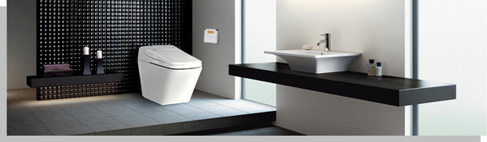](https://vimeo.com/331114389/5ed3820b52)

[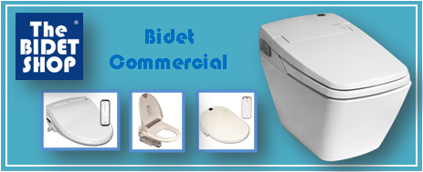](https://vimeo.com/340342816/e97671abd4)[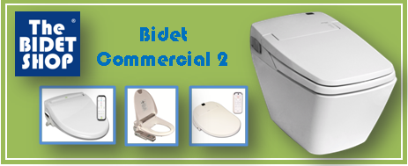](https://vimeo.com/340342841/0ee6de9ce9)Digni